Extracts of my book
Cinderella the Cat, Pluto the Paraplegic Dog
and Foreign Rescue Stories of Hope Fulfilled
Published in July 2012.

INTRODUCTION

OVERCOMING ALL ODDS

All the dogs you’re about to meet in these pages, fate had chosen to abandon by the wayside. Many suffered greatly since they were born on the street, yet they remained amazingly good-natured and gentle, despite experiencing hunger, loneliness, mistreatment, indifference. It was thanks to the kindness of humans, at times divine intervention itself seemed to be the master of the game, that these street dogs’ lives were transformed into rags to riches stories.

I decided to put pen to paper and write about my international dog rescue tales in order to inspire others, to show that even a little effort goes a long way to fulfilling hope.

My own path to rescuing dogs came from working in developing countries, a good career choice on the path to animal activism! Some rescue portraits: the sick dog, Jennie, battered by her hard life, lying on my stairway for days until I gave her a safe haven in Tbilisi, Georgia; the starving puppies, Tina and Tobie (soon part of my African “zoo”), at death’s door on a busy pavement in Freetown, Sierra Leone; Cinderella, my Iraqi cat, sold to me as a scrawny kitten, for $1 by street urchins in Erbil. By the time I took up a post at the European Union in Kosovo in the Balkans, in 2009, where I established a volunteer association, Hope for the Street Dogs of Kosovo, with friends, my animal activism instincts were well honed.

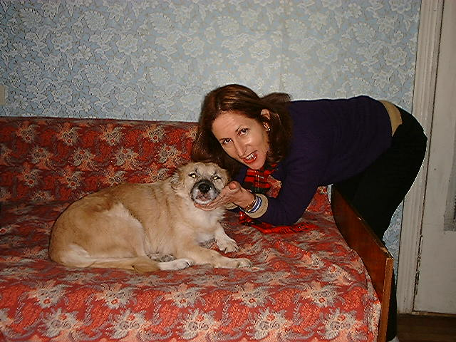

My weekly visit to Jennie, who after a serious ailment, stays at friend’s house to get round the clock care, Tbilisi, Georgia
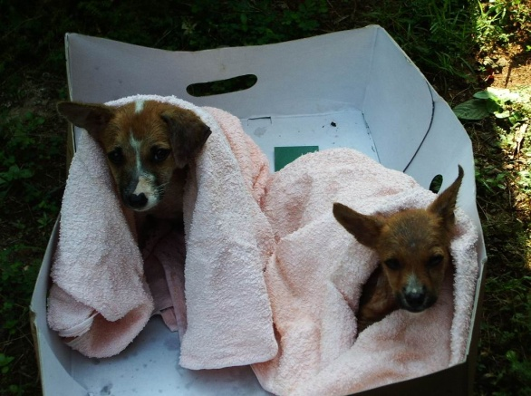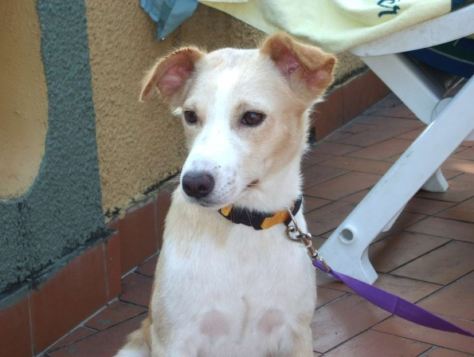

Tobie and Tina, 3 weeks old, a few days after their rescue on the streets of Freetown (left)
Sally lived in the UN parking lot, Freetown, here she’s at the next door hotel pool with me (right)

Rescuing animals not only helps the animals, it brings people and animals together in so many different ways with positive outcomes for both. How many times when you give a treat to a shelter dog, or take him out of his cage for his weekly walk, you are made to feel good about yourself the instant he rewards you with a look that says: “Thanks ever so much. I’m forever grateful.” In most countries outside the United States and Western Europe, there are few well-funded public shelters. So private initiatives like ours run in tandem with Western aid: the latter is targeted at people, our initiative - at the animals. You could classify dog rescue as a branch of public diplomacy promoting our animal welfare values!

The inspiration for this book came in part from reading about the U.S. military adopting dogs and cats in Iraq during their tours of service. This had so much resonance because when I was posted to Erbil, Northern Iraq, in 1997 with a U.N. humanitarian mission, it took much planning, navigating bureaucracies, sharp-witted instincts and sheer good luck to bring my street cat Cinderella back home to New York. The barriers to success seemed invincible – no vets or pet passports available in Erbil in 1997; a five to six hour drive from Erbil to Baghdad driving through Kurdish Democratic Party (PDK) and Saddam Hussein’s Iraqi army front lines; finding a vet in post-sanctions Baghdad; not knowing if Iraqi security would let a cat clear customs to fly on a UN plane Baghdad-Amman; getting a check up at Amman’s best vet clinic; and a sixteen-hour journey back to New York.

Some hair-raising moments when my white cat Cinderella disappears on the Baghdad rooftops two days before her departure; a search party with my friend’s two Sudanese neighbors navigating the rooftops, but shout as we may “Cinderella! Cinderella!” -- both with English and Arabic accents, -- there was no sign of Cinderella. (Finally Cinderella appeared at sunset, a black creature covered in soot navigating the distant rooftops.) The search for a vet in Baghdad ends up in the vast palm groves on the banks of the Tigris River in the middle of which stood a vet clinic for farm animals. Surprisingly, amidst this Biblical scene, the vet produced an international pet passport and a rabies vaccine!

Next day I boarded the United Nations airport bus with Cinderella in a home-made box and arrived at Habbaniyah airport, the venue for UN flights, near Baghdad. The Iraqi security officer asked me: “Do you have anything to declare?” “Just my cat Cinderella, whom I’m taking with me home to New York,” I said, hoping that wouldn’t elicit any statements, such as: “It’s forbidden to export Iraqi dogs and cats.” “That thing,” he said contemptuously pointing at Cinderella. “Take her with you! Please, you’re welcome.” I couldn’t believe my luck.

As I was standing on the tarmac of Habbaniyah airport with Cinderella in my arms, she began to purr loudly as the U.N. plane, visible with its U.N. black logo, started to land on the tarmac. “That’s a natural reaction,” I thought. At least she knew her politics: Saddam Hussein had betrayed and killed the Kurds repeatedly. We were soon in the military plane heading for the peace of Amman, Jordan.

The next morning we visited a modern vet clinic popular with the diplomatic community. The vet examined Cinderella's pet passport: “Oh my God! The vet in Baghdad put the wrong label in the passport! I don’t know what vaccination Cinderella got, but I’m going to give her another rabies vaccine!”

Cinderella was six months old when she left Iraq. When she was one-year-old ginger markings began to appear on her coat. One evening our neighbor, Dale, who owned a pet shop in midtown Manhattan, rang the door bell, a cat pedigree book in hand, and pointed to a photo of a Turkish Van, a rare and ancient breed of cats found around Lake Van in Eastern Turkey. “Look,” she said, “It’s Cinderella!” Indeed the cat was the splitting image of Cinderella, white body with ginger patches and ginger tail. That made sense since Iraqi Kurdistan adjoins Turkey. So I got a pedigree cat at a bargain basement price!

Since then Cinderella has been living the life of a princess in my mother’s Manhattan apartment, although she’s still terrified of doorbells. Once in 1999 she flew all the way to Kazakhstan and back when I was on assignment there for a year, but since then she never wants to leave the apartment. She sits by the window admiring the Manhattan skyline all the way downtown. She even hates going down into our garden. “I love the Big Apple. Who in their right mind would ever want to leave Manhattan?” Cinderella says.
_____

V

SLUMDOG MILLIONAIRES

In March, one month after Hope was established, our first international dog adoption took place. Carlene Salazar, a U.S. Army reservist, from U.S. Camp Bondsteel, the huge airbase that the U.S. began to build during my first tour of Kosovo in 2000-2001, fell in love with Daisy. She phoned Kim to say she wanted to adopt Daisy whose photo she had seen together with those of another shelter puppy, Amber, in the pamphlet Kim had circulated around the U.S. embassy. This was a huge bundle of good news for Daisy.

I had found Daisy, a six-week-old puppy one freezing winter day around December 2009 outside my office window. Cold and hungry she had come wandering into the EU mission compound. Kenny, my colleague from the Close Protection Unit, and I were the only ones feeding the puppy. We decided Daisy was better off at the shelter.

But during weekend visits you could feel the depth of her misery: “You know, every time I pass her cage in quarantine, Daisy seems to say to me, ‘Why did you put me here in this awful place?’ She’s reproaching me,” said Kenny.

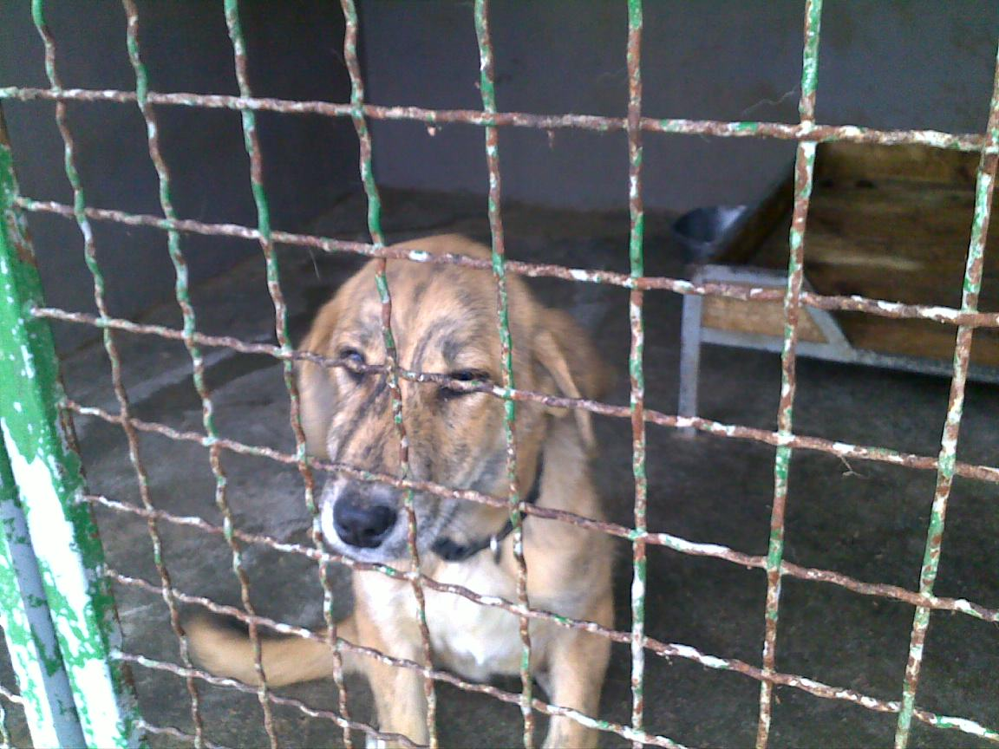

Daisy looking so unhappy in quarantine at the Kosovo shelter

_____

But now Daisy’s fortunes had changed. I had dinner with Carlene to discuss the logistics, which were a bit complicated, but not half as daunting as they would turn out to be. Carlene, and her husband, Brian, who had just retired from the Army, lived on ten acres of wooded property outside Seattle, on the U.S. Pacific coast. But according to U.S. Army rules pets were banned from traveling on U.S. military planes. So when Carlene left Kosovo for good in a few weeks she couldn’t travel with Daisy.

“My husband is flying over from the Pacific coast and we’ll be spending a few days in Frankfurt. If you could somehow get Daisy to Frankfurt that would be great.”

As we ate our main dish I mulled things over:

“You know I have some free Austrian Air mileage, enough for a free travel within Europe. Let’s plan on my bringing Daisy to Frankfurt.”

That was settled. Her husband needed the size of Daisy’s crate and her weight to book her onward flight Frankfurt - Washington DC - Dulles - Seattle. In the meantime, now that Daisy had a home I wanted to get her out of the shelter. Uni and her husband, who was manager for a USAID-funded project, were both Hope volunteers. “We can foster Daisy before her travel to Frankfurt,” Uni told me. That was great. One early morning we drove out to the shelter to pick up Daisy. Boy was she happy to be out her cage and receive love, good food and run around in a garden.

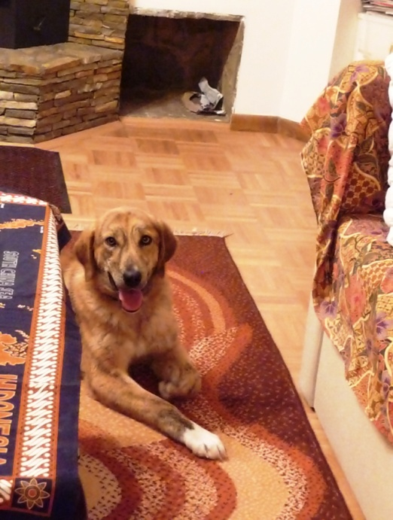

Daisy staying at Uni and Mike’s foster home in Pristina

But dark clouds were looming on the horizon in the form of a high altitude cloud of volcanic ash rising above Iceland and spreading across Europe. Within a few days flights all over Europe were being canceled. Carlene and her husband were in Frankfurt waiting for me to arrive. All plans were ready and our flight hadn’t been cancelled so we went out to the airport as planned. At 3.20 a.m. Ragib our taxi driver and I drove off to Uni’s house up on the next hill. By 4.15 a.m. we arrived at the airport.

“You have to bring a dog two hours before,” an Austrian Airways had told us.

Unfortunately, the news was not good. When the Austrian Airlines counter opened at 5 a.m. the representative said all flights from Pristina were cancelled due to the cloud of volcanic ash that winds were carrying over Europe’s skies.

Uni and I were really distraught. We left the airport at 5.30 a.m., but thanks to the dedication of Uni and her husband, and Brian and Carlene’s unwavering enthusiasm to adopt Daisy, I started to develop plan B.
_____

In the meantime, the second day after Carlene decided to adopt Daisy she called Kim to tell her she had rescued another half-starved puppy on the streets of Pristina. Not one to ever say “no” to helping a dog in need, Kim now had four dogs, including Bravo, a small black dog who had been living outside the gates of the U.S. embassy for a year, who yelped at every guest. Carlene said her husband Brian could pick up Rosie around early June 2010 when Kim would be flying home to Washington DC.

Lucky for Daisy, I was flying home to New York at the end of April so Daisy only had to wait around ten more days to travel. I rebooked her flight. But the new logistics were also a bit complicated. Brian would fly all the way across the U.S. to Dulles Airport then would then drive down to New York JFK to pick up Daisy after my flight landed.

Once again I was hoping there wouldn’t be any glitches. An email from Carlene read: “Please make sure you wait just inside the main gate of Terminal 1 as there’s no parking at all on the curb, so when my husband arrives you’ll have a few minutes to put Daisy in the car.”

The U.S. customs official was very friendly and I was soon in the Terminal 1 arrival hall. I was standing there watering Daisy when a volunteer, Helga, from the JFK Travelers’ Aid visitors desk came over and started looking into the carrier: “Oh what a darling dog. Where did you both come from?” I avoided the word “shelter” because people can have strange ideas. But Helga’s enthusiasm was unwavering:

“She’s beautiful. Maybe you should walk her after such a long trip.”

She then took over Daisy’s care asking her co workers if they could take a minute to walk Daisy outside. Everyone was busy so she volunteered: “Let me walk her outside. I’m a volunteer at the Queens ASPCA.”

Brian called that he would arrive in a minute, while Helga and I were chatting. In a few minutes he drove up to the curve. We all tried to put the carrier in his car but it wouldn’t fit in. Helga was clearly taken with Daisy and was now fully committed to our operation.

“I’ve got an idea. Why don’t we dismantle the carrier and reassemble it in the car itself,” I suggested

I held Daisy on a leash while Helga and Brian reassembled carrier together at the back of the car. During this short-lived operation Helga managed to find out Daisy’s entire history from Brian.

In the meantime, a police officer was blowing his whistle, signaling for Brian to move.

I bid farewell to Hope’s first adoptee, putting my arms around her and said: “Good luck Daisy!” I snapped some photos of Daisy as she drove off forever to her new life.

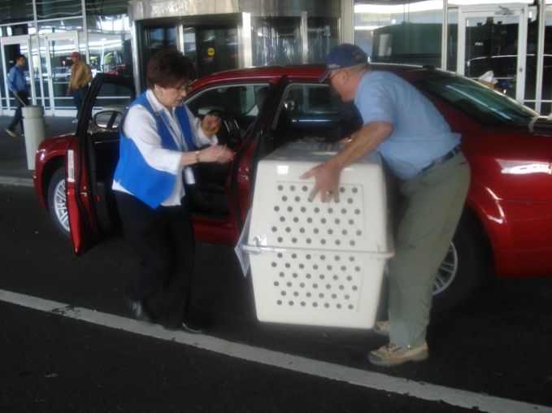

Brian and Helga trying unsuccessfully to load Daisy at JFK airport

A few weeks later Kim flew with Rosie to Dulles Airport and Rosie, the second street dog from Kosovo, landed on U.S. soil. Brian picked her up and they headed for the next part of her long flight home to Seattle.
_____

Some months later Hope received an email and photos of both dogs enjoying the freedom of a large property.

Hi All,
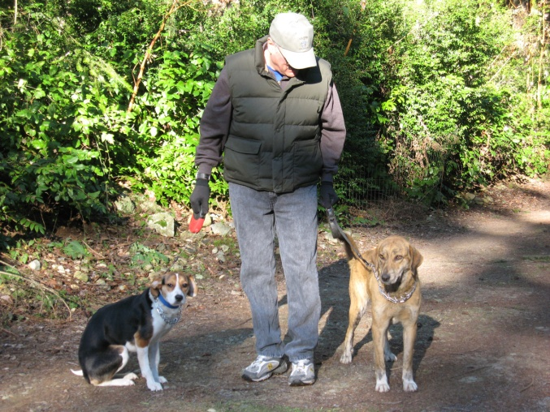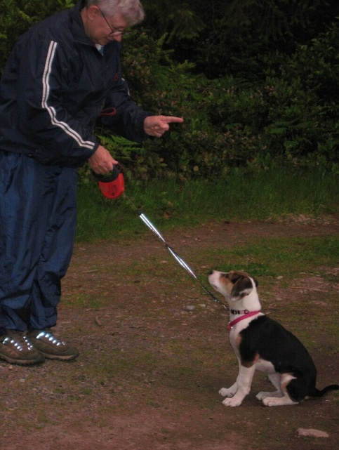

Daisy and Rosie with Brian on his property near Seattle

Thought you'd like to know Rosie came through her surgery … to lengthen her leg bone that didn't grow correctly due to her original injury. Prognosis is good for at least a near full recovery, since she's young enough. She would never have recovered in Kosovo
The surgery and follow-on treatment is only offered in Seattle. Total cost will be around $3,500 and $4,000, not including travel, medications and IP X-rays. This was the ONLY way she could recover full use. She is one very fortunate puppy!
Daisy is really doing well. She loves her walks and to play. Her favorite toy is a blue knobby toss toy that squeaks. She'll toss it in the air and catch it, then run around with it in her mouth…
_____

